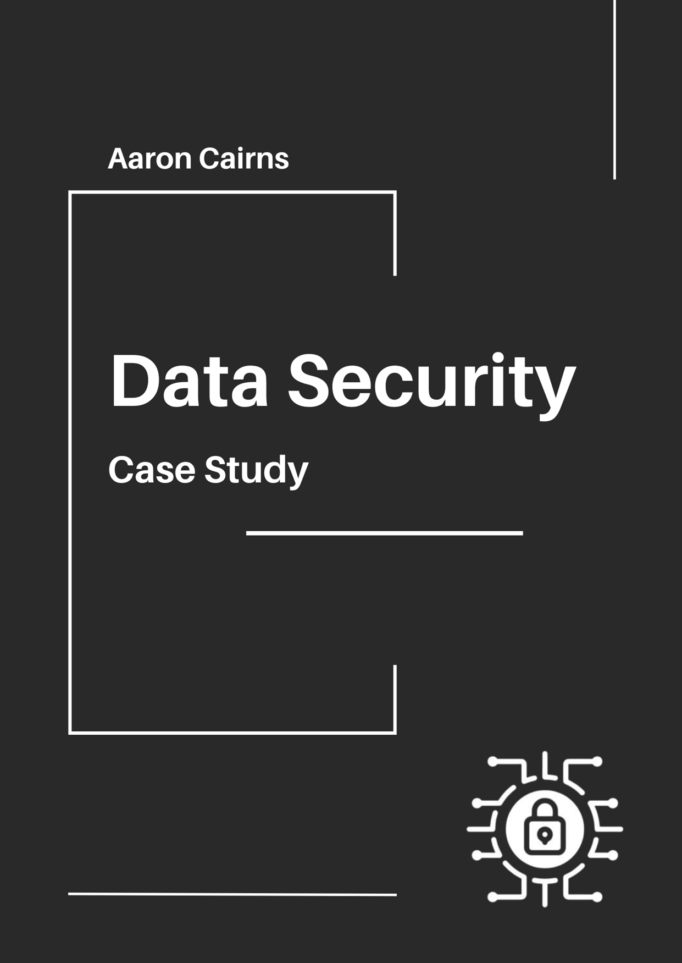
Contents

Findings 2
Data protection and risk identification 3
Boundary firewalls and internet gateways 4
Securing the configuration 5
Access controls 6
Malware protection 7
Patch management 8
Conclusion 9
References 10

Findings

I have been tasked to write a report on Malcolm’s company ‘The Tyre & Exhaust Centre’ and their risk of being exposed to cyber-attacks.

Information about the company set up:

- Devices: 3 Computers

- 1st Office computer use: Accounts, VAT returns, Tax and dealing with suppliers (Windows 7)

- 2nd Office computer use: Stock control for parts (Windows 7)

- 3rd reception computer: Customer records, appointments (Windows 10)

- Reception computer access: Full time receptionist, mechanics share log ins to document phone appointments when receptionist is gone

- 2nd Office computer access: 7 mechanics with same log ins

- Network: Open Wi-Fi for customers to use their own devices as 3G/4G connection is bad inside building

Data protection and risk identification

The tyre and exhaust centre (TEC) handle important information such as financial records, stock control, customer records and appointments. This data is also stored over multiple different devices in different areas of the building, while having different forms of staff having access to certain devices:

• 1 Office computer to deal with account, VAT returns, tax and service for suppliers, while all being on Windows 7 for the OS.
• 1 Office computer to deal with stock control for parts, Windows 7 OS is also used on this device.
• Reception computer to deal with phone appointments and customer records with shared log ins, Windows 10 OS on this device.

The data that the TEC holds are a vital part of the company’s infrastructure and success, the data can be very valuable to the likes of cyber criminals and hackers such as personal information, financial assets, possible data theft and ransomware attacks and these can all majorly impact the company from functioning properly and smoothly.

TEC deciding to use very outdated operating systems massively increases the risk of falling victim to a cyber-attack as Windows 7 is no longer being updated in all areas of the OS including the security software. The next risk would be the shared log ins between the receptionist and the office stock control computers, which can create chances and risks of unauthorised access to these systems.

The final main risk is the public open wi-fi for customers, which can create a route for hackers to expose the network from an external device, which can possibly be one of the most dangerous forms of attack as it can be harder to not only detect an unwanted presence, but the hacker can prepare more on their own systems to prevent detection from the company and police.

Boundary firewalls and internet gateways

The security of the network TEC provides most likely does not have a very secure or strong firewall with it being an open wi-fi. This is very concerning as it can be easily accessed by any unauthorised devices, making it easy for cyber criminals to attack the company’s data. Another issue is the fact that the password for any firewall or security is the default password.

Some basic changes to help secure TECs security:

• Change the admin password for the firewall to something different while making it strong by involving a minimum of capital letters, numbers and symbols.
• Make sure only the admin knows the password and it does not get shared.
• Changes and additions to the firewall must be approved by an authorised personnel member and then be documented in a safe place.

These are some of the most important changes TEC should make to help secure the infrastructure from any form of cyber-attacks; however, they still have plenty of improvements to be made. They can tackle the services that are allowed past the firewall by blocking vulnerable services at the firewall by default, like SMB, NeTBUOS and RSH.

The admin should make sure that the access and control of the firewall is no longer able to be viewed or accessed by anyone on the network and make it so the firewall settings are on a separate system, so only the admin can change anything.

They should also consider getting a separate network from the open wi-fi that separates the workers and the public from using the same network and exposing weak points in the networks.

Securing the configuration

For the layout of TEC, there are multiple issues with the configuration. First are the office computers, as both office computers share a default password for all users and the same for the receptionist’s computer.

Some ideas to tackle some of the issues involved:

• Change all user passwords to something unique and strong (capital letters, numbers and symbols).
• Unnecessary user accounts to be removed or disabled.

Another issue involved is the unnecessary amount of software programs that will be automatically running on start-up, with most of these applications running hidden in the background without the user’s knowledge. Another issue in security is all the unnecessary programs and software installed on all the computers.

Some ideas to tackle more of the issues involved:

• Remove or disable any unnecessary user accounts that may be still on the system.
• Disable all the auto-run features on all computers in the offices and reception.
• Uninstall any unnecessary programs/software that could become a potential threat to security.

All computers owned and used by TEC employees should have their own personal firewalls activated and configured to the computer it is running on, to block any unwanted or unapproved connections/applications by default.

Access controls

There are a lot of security issues surrounding who has access to what systems. For example, multiple shared log-ins for both the stock control computer and the reception computer, and there is plenty they can do to secure most of these security threats. To begin with, they can start restricting user accounts by subjecting all user accounts to an approval process, which would be handled either by the company manager or an experienced and trusted person within the ICT department if available, whilst keeping copies of all approval processes, outcome of approval, user details.

Access to special files/documents should only be restricted to a select number of individuals who are trusted and experienced in TEC, for example, the manager and the head of the ICT department. All details of someone being granted special access should be documented every time they have accessed special documents, with the time and name of the individual, the department they work in, and what exactly they were accessing and doing in the document in sufficient detail, while keeping all of this information in a locked and secure location, and remembering to review all of these documents in a frequent manner, for example, every 30 days.

All administrative accounts should only be used when performing legitimate admin activities, while remaining off the network and refused to be granted any form of public services. All admin and user accounts should all be required to have strong unique usernames and passwords and have them changed on a regular basis to be granted access to anything.

All user accounts and special access privileges should be removed or disabled when the user is demoted from being an admin, leaves the workplace or is on leave for a period of time. This will prevent any security risk from breach of a previous user's idle accounts, accidental information leak or data theft captured via a user who may have an active account but is on leave for a temporary period of time.

Malware protection

After evaluating the situation, TEC, with their lack of security and very outdated operating systems and software, it’s easy to assume that they will not have any malware protection or an outdated version of one. This should be handled right away.

The first area to be worked on is, once the OS has been updated to a current version of either Windows 10 or 11, is to get an up-to-date version of malware protection that is still receiving future updates and keep the software connected to the internet to make sure all future updates can be implemented right away.

The malware protection used should be made to scan all files automatically upon access and allowed to scan web pages that are trying to be accessed to make all work security and processes run more smoothly. The malware protection should be configured to perform full scans on a regular basis. For the best protection, it should be set up to perform a full scan daily.

Having malware protection scanning all your files on a regular basis will help catch any possible spyware and adware. By removing/preventing any spyware or adware, this will greatly increase the performance of the computing systems being used, which in return will also increase the performance of the work itself.

Malware protection will also combat and prevent any form of ransomware, which can be detrimental to the company as it can put Malcolm in a position of needing to pay the attacker or put his company at risk to retrieve some stolen information, which is almost always confidential and/or important data. Having customer information or employee information exposed or stolen can cause any company to slowly decline in sales and popularity.

The malware protection should be allowed to prevent any connections to any malicious websites on the network; this can be done by using something called website blacklisting.

Patch management

Patch management is a very important part of security; however, there are plenty of issues that are affecting TEC’s security. First are the outdated operating systems that two of the computers are using. Two out of three computers are using Windows 7, which is no longer supported by Microsoft, meaning no more security or software updates. This is a very big risk as it makes those systems very vulnerable to all forms of cyber-attacks.

Any other forms of software that aren’t being supported by the developers should be removed from the systems, as these can be easily exposed and used against the company if the software is no longer receiving any more updates.

Recommendations on resolving these issues:

• Updating the OS to a supported software like Windows 10 or 11 and licensed by the correct vendor.
• All security updates should be made as soon as the update is available.
• Uninstall any software that is no longer needed.
• Uninstall any software that is no longer getting regular updates or is no longer being supported.

All staff should be trained and educated on the importance of patch management and keeping everything up to date. They should also be aware of the importance of reporting any issues that may occur with some updates, installing, and removal of software.

Starting with these recommendations will greatly strengthen TEC’s security overall by reducing any vulnerabilities and guarding themselves against most forms of cyber-attacks and threats.

Conclusion

Being able to tackle all forms of cyber threats and attacks is such an important component to keeping a company, employees and the customers safe. This means having all the employees being knowledgeable on IT and making sure TEC’s data is secure is critical to the company’s success and stability. The current issues within Malcolm’s company, including out-of-date software and OS, unsecure access control, shared log-ins and a lack of malware protection, causes a big security risk for financial information and customer data.

Excluding the possible cybersecurity threats, TEC must stay in compliance with the General Data Protection Regulation (GDPR) regulation. This means that Malcolm and TEC have an obligation to make sure that all customer data is handled securely and safely. Refusing to comply with the GDPR regulation can result in severe fines and can also be severe to TEC’s reputation. Therefore, taking steps to make sure the company stays in compliance with the GDPR regulations is incredibly important.

By making sure that all the operating systems are updated and supported, passwords are changed to strong and unique passwords, isolating the network and competent malware protection, TEC can decrease the chances of having any cyber-attacks and thefts while staying in compliance with the GDPR regulations.

Cyber-attacks are a growing threat and security against attackers is always being updated and changed, meaning that TEC has to remain aware at all times to make sure that the company and their systems are always protected and updated. By doing all of this while not breaching GDPR, TEC can run efficiently while maintaining customer trust and allow the company to build its infrastructure and expand its business in the future without a high chance of risk from their digital platforms.

References

Microsoft. [Online]
Available at: https://learn.microsoft.com/en-us/troubleshoot/windows-client/windows-7-eos-faq/windows-7-end-support-faq-general

Cyber and infrastructure security agency (CISA), n.d. [Online]
Available at: https://www.cisa.gov/news-events/alerts/2013/06/24/risks-default-passwords-internet

Intel, n.d. [Online]
Available at: https://www.intel.com/content/www/us/en/business/enterprise-computers/resources/patch-management.html

Kaspersky, n.d. [Online]
Available at: https://www.kaspersky.com/resource-center/preemptive-safety/public-wifi-risks

Office of Innovative Technologies, n.d. [Online]
Available at: https://oit.utk.edu/security/learning-library/article-archive/avoiding-shared-accounts/

